Gloucestershire Lettering Arts Workshop Booking Form

17 October 2026 – Interpretation – four ways – Peter Lloyd
Gambier Parry Hall, Highnam, Glos. 10am 'til 4pm

Applications must be received by 11 October 2026. Should the workshop be over-subscribed a ballot will be made to determine the order in which places will be allocated. If space is available, applications received after the ballot date will be considered, but no guarantee can be given that you will receive exemplars etc. provided by the tutor.
PLEASE NOTE The full fee is non-returnable unless the workshop/event is cancelled by GLA, in which case a full refund will be made. In the case of illness etc., it is the responsibility of the person withdrawing to contact the Bookings Secretary (Josie Brown). If a replacement cannot be found and providing the workshop expenses are covered, in certain circumstances, the booking fee may be refunded. This is at the discretion of the committee.
This workshop will cost £42 . There will be a minimum requirement for 10 places or the day may have to be cancelled. If you need confirmation of your booking please include either your email address or a SAE.

Description:
This workshop offers you the opportunity to explore different techniques to become more expressive with your calligraphy. To add impact, atmosphere, rhythm and punctuation to develop how you communicate your message to the reader.
Together we will have fun highlighting specific words and phrases using size, weight, colour and style to break free from a simple page of text.
Please bring along your own favourite poem, prose or verse.

Materials Required:
Your normal calligraphy equipment plus
Colour pencils, inks, paints, colour pens – whichever you prefer
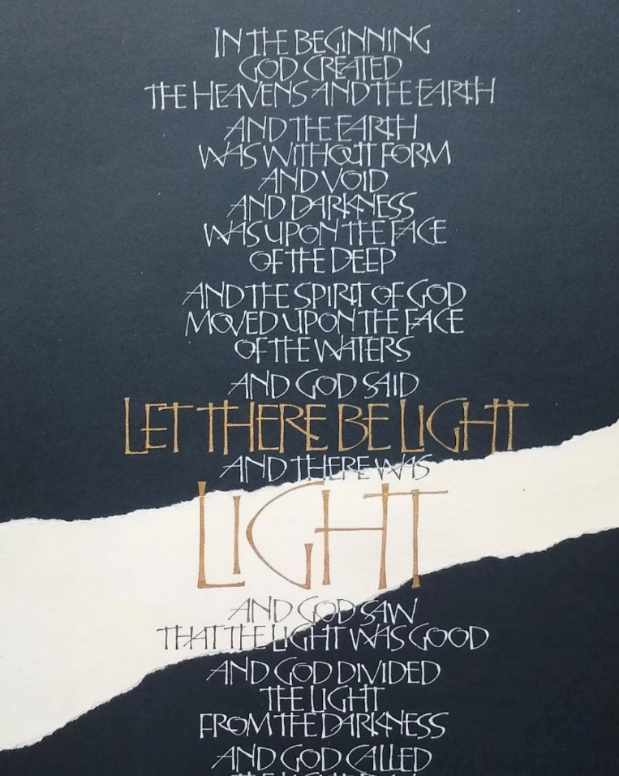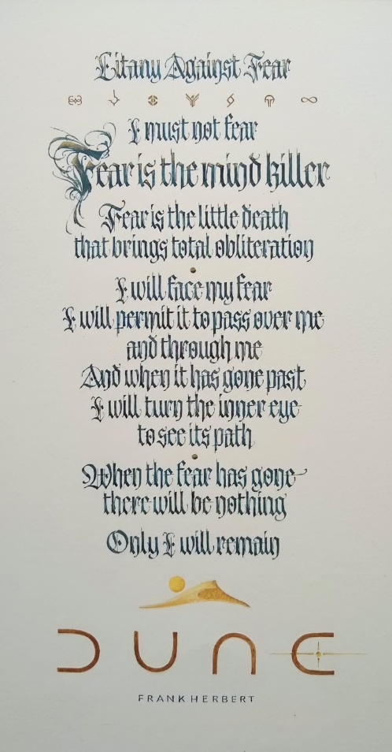

BOOKING FORM
Please enrol me on Peter Lloyd’s Interpretation – four ways workshop.
If possible please pay by bank transfer to: Acc Name: GLA
Sort Code: 30-95-72
Acc Number: 35161468
Ref: OCT 26 GLA WS

and then return this booking slip once transferred to josie.brown53@gmail.com (you can save the slip as a separate document just by highlighting and deleting everything on the previous page)
or enclose a cheque for £42 made payable to Gloucestershire Lettering Arts (or GLA) and post to Josie Brown at Mill Barn, St Owens Cross, Hereford, HR2 8LG

Separate payments must be made for each workshop

Please put X in the method of payment below that applies to you:

I have paid by bank transfer, and I have included the reference given above
I am including a cheque with the name of the workshop on the back

I understand the refund rules stated above.
NAME |  | SIGNED
EMAIL |  | TELEPHONE

Please put X to show how you would like confirmation of your place:

I would like confirmation by post, and I have included an s.a.e.
I would like confirmation by email

