Gloucestershire Lettering Arts Workshop Booking Form

Silver Leaf Gilding and Painting Techniques for Lettering
Tanja Bolenz – 21 November 2026
Gambier Parry Hall, Highnam, Glos. 10am 'til 4pm

Applications must be received by 13 November 2026. Should the workshop be over-subscribed a ballot will be made to determine the order in which places will be allocated. If space is available, applications received after the ballot date will be considered, but no guarantee can be given that you will receive exemplars etc. provided by the tutor.
PLEASE NOTE The full fee is non-returnable unless the workshop/event is cancelled by GLA, in which case a full refund will be made. In the case of illness etc., it is the responsibility of the person withdrawing to contact the Bookings Secretary (Josie Brown). If a replacement cannot be found and providing the workshop expenses are covered, in certain circumstances, the booking fee may be refunded. This is at the discretion of the committee.
This workshop will cost £42 . There will be a minimum requirement for 10 places or the day may have to be cancelled. If you need confirmation of your booking please include either your email address or a SAE.

Description:
The aim of this workshop is to explore and play with positive and negative space in order to create exciting lettering tapestries. Silver leaf gilding in the form of edging letters and creating letters within letters using silver to enhance and highlight letters will be an integral part in this workshop. Participants will get a better understanding of looking at and integrating foreground and background (positive and negative space) and how to incorporate this knowledge into all kinds of lettering projects. Various exercises will begin the design process for creating two miniature lettering tapestries, using a variety of tools from double-pencils, large broad edged nibs, automatic pens, etc. an easy way of drawing chunky capitals using a skeleton basis will be demonstrated. We will then explore several ways of gilding and 2 different painting and decorating techniques using watercolours. No previous experience in lettering is required.

Materials Required:
- Watercolours
- Chinese Ink
- Broad-edged nibs, large
- Automatic Pens, no. 3 & 4
- HB Pencil
- Broad-edged felt pens, 5 mm wide
- Pointed brushes, no. 0,1,2 (ideally of good quality)
- Old or cheap pointed brush to work with resist
- Resist
- Non sticky tape
- Paper: smooth, HP, 320 gsm or similar. We’ll need 3 pieces of paper: 160mm x 120mm and somewhat larger sized mount board or book binders board to mount the pieces of paper on
- other essentials: ruler, set square (only if you have one), mixing trays, water jar, rag, scissors, paper towel
If you have please bring:
- Gum ammoniac
- PVA
- Transfer Silver Leaf
Otherwise you can purchase small amounts from the tutor for a nominal charge.
Optional:
- Agate burnisher for polishing silver

SUGGESTED PREPARATION:
Give each sheet a very light yellow wash.
Think of three short words, could be seasonal or anything else.
Examples of what the tutor will be showing you:
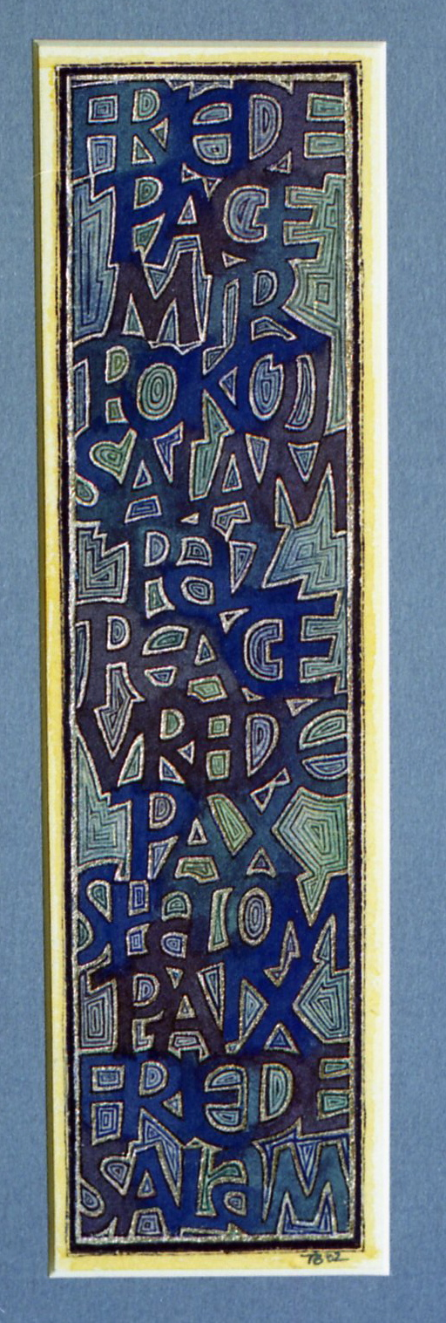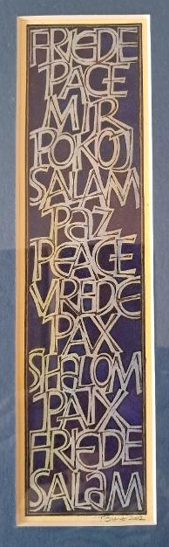
BOOKING FORM
Please enrol me on Tanja’s Silver Leaf Gilding and Painting Techniques for Lettering workshop.
If possible please pay by bank transfer to: Acc Name: GLA
Sort Code: 30-95-72
Acc Number: 35161468
Ref: NOV 26 GLA WS

and then return this booking slip once transferred to josie.brown53@gmail.com (you can save the slip as a separate document just by highlighting and deleting everything on the previous page)
or enclose a cheque for £42 made payable to Gloucestershire Lettering Arts (or GLA) and post to Josie Brown at Mill Barn, St Owens Cross, Hereford, HR2 8LG

Separate payments must be made for each workshop

Please put X in the method of payment below that applies to you:

I have paid by bank transfer, and I have included the reference given above
I am including a cheque with the name of the workshop on the back

I understand the refund rules stated above.
NAME |  | SIGNED
EMAIL |  | TELEPHONE

Please put X to show how you would like confirmation of your place:

I would like confirmation by post, and I have included an s.a.e.
I would like confirmation by email

