Gloucestershire Lettering Arts Workshop Booking Form

20 June 2026 – Art Nouveau-style Illuminated Initial – Vanessa Peters
Gambier Parry Hall, Highnam, Glos. 10am 'til 4pm

Applications must be received by 17 June 2026. Should the workshop be over-subscribed a ballot will be made to determine the order in which places will be allocated. If space is available, applications received after the ballot date will be considered, but no guarantee can be given that you will receive exemplars etc. provided by the tutor.
PLEASE NOTE The full fee is non-returnable unless the workshop/event is cancelled by GLA, in which case a full refund will be made. In the case of illness etc., it is the responsibility of the person withdrawing to contact the Bookings Secretary (Josie Brown). If a replacement cannot be found and providing the workshop expenses are covered, in certain circumstances, the booking fee may be refunded. This is at the discretion of the committee.
This workshop will cost £42 . There will be a minimum requirement for 10 places or the day may have to be cancelled. If you need confirmation of your booking please include either your email address or a SAE.

Description:
This workshop will focus on the works of Alphonse Mucha and George Riom, both prolific artists of the Art Nouveau era, as inspiration for producing a gilded or gold painted letter with an Art Nouveau style flower design, using a delicate palette of colours and sensitive watercolour techniques. You don’t have to use real gold leaf, but Vanessa will take those who wish to, through the processes involved in laying a modern gilding medium and applying the gold leaf or imitation gold – a method that promises guaranteed success – as well as subtle ways with watercolour to give you a wholly different approach to an illuminated letter.

Materials Required:
- Smooth (HP) white/cream watercolour paper* - 300gsm A5
- Optional - PVA (bookbinders if possible) or similar gilding size/mordant* (eg Miniatum)
- Optional - Gold leaf or imitation gold metal leaf*
- Optional - Glassine*
- If gilding - some scraps/spares of preferred paper for colour/mordant testing
- Tracing paper or transfer paper for copying image
- Watercolour paints of various colours (ideally, ‘warm’ primary colours Cad. Yellow, Cad Red, French Ultramarine)*
- A mapping pen, pointed calligraphy nib or fineliner
- One or two small size paint brushes suitable for painting fine detail (as a guide size 0 or size 1 rounded brush)
- If gilding - small inexpensive brush for applying gilding size
- Pencil, ruler, eraser, pencil sharpener
- Metallic gold paint such as Finetec, if you’re not going to gild
- Paint palette or saucer
- Water container
- Kitchen roll
- If glasses or magnifiers are helpful for you for detailed work, then bring them
- You may wish to combine some calligraphy with your finished piece, in which case bring along some of your preferred calligraphy pens & inks

*Please do not purchase any of these items especially for the workshop. Your tutor will have a supply of these to borrow/purchase on the day.
** Both PVA and Isopropanol can be a mild irritant or drying to particularly sensitive skin

Images on the following page

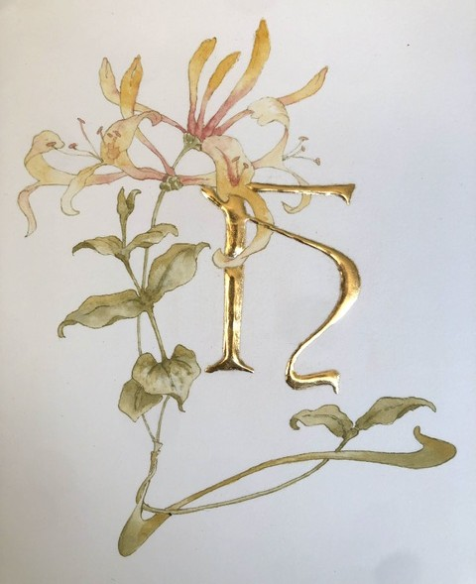
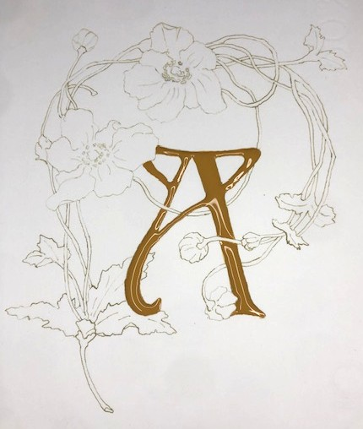
BOOKING FORM
Please enrol me on Vanessa Peters’ Art Nouveau-style Illuminated Initial workshop.
If possible please pay by bank transfer to: Acc Name: GLA
Sort Code: 30-95-72
Acc Number: 35161468
Ref: JUNE 26 GLA WS

and then return this booking slip once transferred to josie.brown53@gmail.com (you can save the slip as a separate document just by highlighting and deleting everything on the previous page/s)
or enclose a cheque for £42 made payable to Gloucestershire Lettering Arts (or GLA) and post to Josie Brown at Mill Barn, St Owens Cross, Hereford, HR2 8LG

Separate payments must be made for each workshop

Please put X in the method of payment below that applies to you:

I have paid by bank transfer, and I have included the reference given above
I am including a cheque with the name of the workshop on the back

I understand the refund rules stated above.
NAME |  | SIGNED
EMAIL |  | TELEPHONE

Please put X to show how you would like confirmation of your place:

I would like confirmation by post, and I have included an s.a.e.
I would like confirmation by email

