Gloucestershire Lettering Arts Workshop Booking Form

16 May 2026 – Taking a Line for a Walk – concertina maps with Chrissie Nicholls
Gambier Parry Hall, Highnam, Glos. 10am 'til 4pm

Applications must be received by 9 May 2026. Should the workshop be over-subscribed a ballot will be made to determine the order in which places will be allocated. If space is available, applications received after the ballot date will be considered, but no guarantee can be given that you will receive exemplars etc. provided by the tutor.
PLEASE NOTE The full fee is non-returnable unless the workshop/event is cancelled by GLA, in which case a full refund will be made. In the case of illness etc., it is the responsibility of the person withdrawing to contact the Bookings Secretary (Josie Brown). If a replacement cannot be found and providing the workshop expenses are covered, in certain circumstances, the booking fee may be refunded. This is at the discretion of the committee.
This workshop will £42 . There will be a minimum requirement for 10 places or the day may have to be cancelled. If you need confirmation of your booking please include either your email address or a SAE.

Description:
Take a line for a walk in this mapping workshop with Chrissie Nicholls of Inkpot & Pen.
Bring an imaginative or real journey with you, design and create your own linear map with a cartouche and compass rose, finishing the workshop by binding your map into an artists’ concertina book. Chrissie works as both an illustrator and lettering artist, and will guide and support students throughout the workshop to create a unique personal map.

You can bring any idea with you; perhaps you’d like to record an enjoyable day, a secret walk, a holiday with all its memories, or the dream of a perfect garden. We’ll bring those ideas and memories to life. Bring any kind of reference materials along, be it newspaper cuttings, tickets or photos on your phone and your creative spirit.

Ideal to design as a gift for a loved one, to celebrate an occasion, or as a collection of memories. No experience required, just an open mind to be curious.

Materials Required:
The tutor will provide the paper (160 gsm) for the workshop ready-cut to size. You’ll be working on 160gsm paper, so light watercolour paint will work, as will colour pencils.
- Colour pencils/coloured markers/watercolour or gouache paints (and brushes if using paints)
- Graphite pencils
- Fine liners of varying thickness or colours
- A range of nibs – broad / pointed / cola or ruling pen – whatever you like writing with best
- Brush pens if you like using them
- A favourite ink / paint to write with
- Bone or Teflon folder
- Pair of compasses or small circle stencil (for circles approx. 30 and 18 mm)
- Square stencil if you have one
- Ruler

See images on following page for an indication of what the day will involve – your booking slip is on page 3 – you only need to return that to Josie (save this document, the fill out your own details and delete pages 1 and 2, before saving the booking slip, separately, to send off).

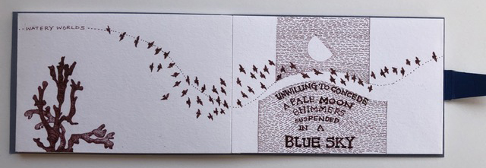

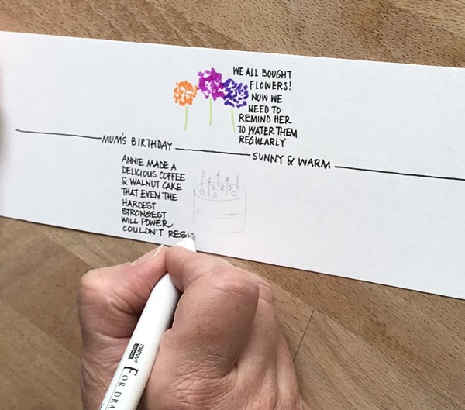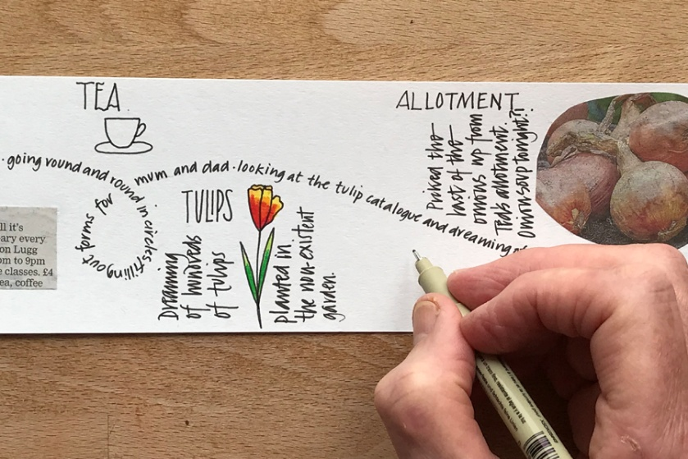

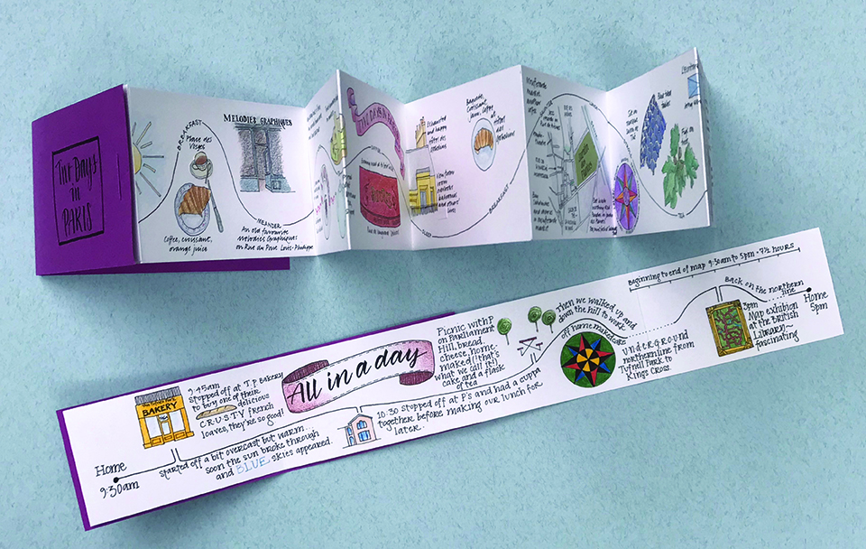

BOOKING FORM
Please enrol me on Chrissie Nicholls’ Take a Line for a Walk – concertina maps workshop.
If possible please pay by bank transfer to: Acc Name: GLA
Sort Code: 30-95-72
Acc Number: 35161468
Ref: MAY 2026 GLA WS

and then return this booking slip once transferred to josie.brown53@gmail.com (you can save the slip as a separate document just by highlighting and deleting everything on the previous pages)
or enclose a cheque for £42made payable to Gloucestershire Lettering Arts (or GLA) and post to Josie Brown at Mill Barn, St Owens Cross, Hereford, HR2 8LG

Separate payments must be made for each workshop

Please put X in the method of payment below that applies to you:

I have paid by bank transfer, and I have included the reference given above
I am including a cheque with the name of the workshop on the back

I understand the refund rules stated above.
NAME |  | SIGNED
EMAIL |  | TELEPHONE

Please put X to show how you would like confirmation of your place:

I would like confirmation by post, and I have included an s.a.e.
I would like confirmation by email

