Gloucestershire Lettering Arts Workshop Booking Form

21 March 2026 – Rotunda with Bejewelled Letters – Gwyneth Hibbett
Gambier Parry Hall, Highnam, Glos. 10am 'til 4pm

Applications must be received by 15 March 2026. Should the workshop be over-subscribed a ballot will be made to determine the order in which places will be allocated. If space is available, applications received after the ballot date will be considered, but no guarantee can be given that you will receive exemplars etc. provided by the tutor.
PLEASE NOTE The full fee is non-returnable unless the workshop/event is cancelled by GLA, in which case a full refund will be made. In the case of illness etc., it is the responsibility of the person withdrawing to contact the Bookings Secretary (Josie Brown). If a replacement cannot be found and providing the workshop expenses are covered, in certain circumstances, the booking fee may be refunded. This is at the discretion of the committee.
This workshop will cost £42 . There will be a minimum requirement for 10 places or the day may have to be cancelled. If you need confirmation of your booking please include either your email address or a SAE.

Description:

The Rotunda script is a rounded type of gothic, which is much less angular and compressed than other gothic hands. It is mainly seen in manuscripts from southern Europe of the Middle Ages. Often the borders of manuscripts from this time were richly decorated with painted gemstones and jewels.
Taking both these elements, this workshop explores Rotunda lettering and how it is constructed, and then uses some simple drawing techniques add some fantastical jewels to your lettering

Materials Required:
- Pencil, eraser, ruler, double pencil ( 2 pencils taped together)
- Broad edged nibs of a variety of sizes between 3mm (Mitchell #1) and 1mm (Mitchell #3 ½)
- Ink
- Paper – cartridge paper is suitable.
- Watercolour or gouache paints in a range of colours. If you have gold watercolour or gouache paint please bring this along (I will have spare so don’t worry if you don’t)
- Coloured pencils, especially water soluble ones are good to bring along too
- Small, paintbrush(es) that taper to a point and can be used for fine detail
- Some opaque white paint, such as permenant white gouache, Dr Martins bleedproof white or similar
- Something to use as a palette & a water container
- Some sheets of kitchen roll
- Fine tipped, waterproof fineliner (optional)
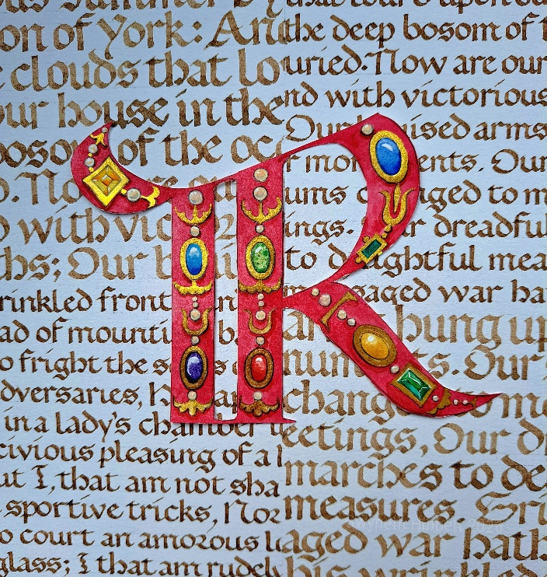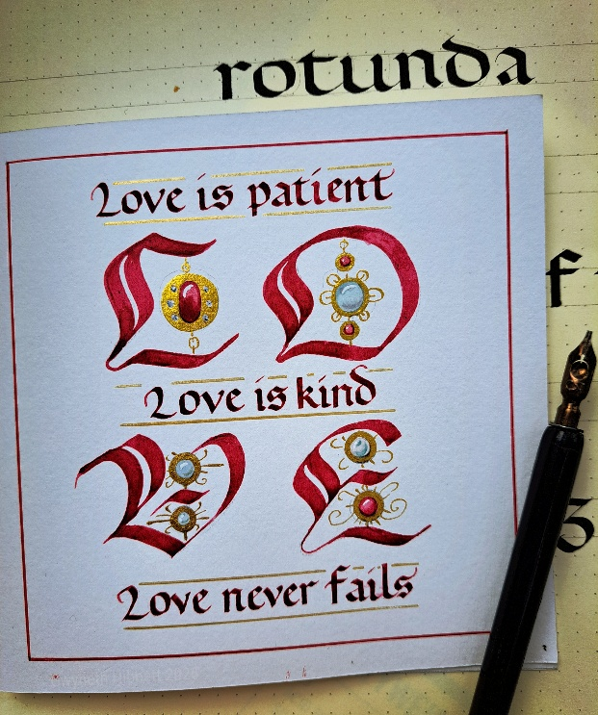
BOOKING FORM
Please enrol me on Gwyneth Hibbett’s Rotunda with bejewelled Letters workshop.
If possible please pay by bank transfer to: Acc Name: GLA
Sort Code: 30-95-72
Acc Number: 35161468
Ref: MAR 26 GLA WS

and then return this booking slip once transferred to josie.brown53@gmail.com (you can save the slip as a separate document just by highlighting and deleting everything on the previous page)
or enclose a cheque for £42 made payable to Gloucestershire Lettering Arts (or GLA) and post to Josie Brown at Mill Barn, St Owens Cross, Hereford, HR2 8LG

Separate payments must be made for each workshop

Please put X in the method of payment below that applies to you:

I have paid by bank transfer, and I have included the reference given above
I am including a cheque with the name of the workshop on the back

I understand the refund rules stated above.
NAME |  | SIGNED
EMAIL |  | TELEPHONE

Please put X to show how you would like confirmation of your place:

I would like confirmation by post, and I have included an s.a.e.
I would like confirmation by email

